*MongoDB Session:*

Is a Node.js package used to store session data in MongoDB for Express applications. It works with express-session to provide persistent session storage in a MongoDB database, allowing you to manage user sessions across requests.

*Step 1:*

Install connect-mongodb-session package to create and store session in mogodb as shown in below screenshot.

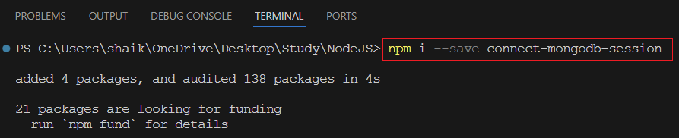

*Step 2:*

Import package and create store with collection name & add store in middleware as shown below screenshot

